**CloudPlatform**



CloudPlatform

Self-service desktops

How to integrate CloudPlatform with XenDesktop

by script to enable self-service desktops

  
www.citrix.com

Objectives

CloudPlatform is a comprehensive cloud management solution which includes self-service capabilities. Many customers want to leverage self-service functionality for their virtual desktop installations to provide a portal where the user can select the desktop flavor he requires. In addition it should give the users more control over their desktops like start, stop, reboot, console access, network attach, attach iso, attach volumes, console access and more. At the same time the performance to access the desktop should be optimal – hence XenDesktop with HDX capabilities should be used.

This article describes how CloudPlatform can be integrated with XenDesktop by script to provide this functionality. The drawing should give you an idea of the workflow and communication process.

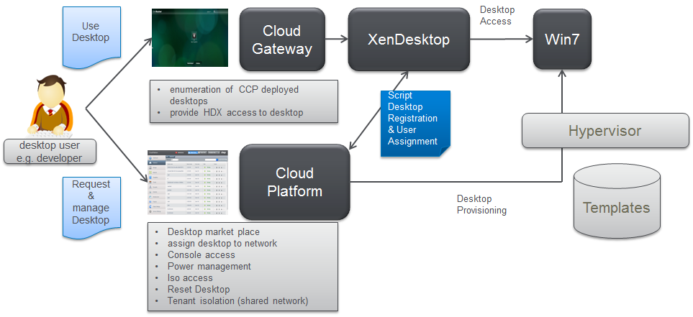

Preparation of the XenDesktop environment

Obviously a XenDesktop installation is required for this functionality. As there’s no difference to a default XenDesktop installation this part is not covered in this article. Please refer to the official XenDesktop installation for more information on how to setup XenDesktop. The configuration has been tested with XenDesktop 5.6 but should work with other versions as well as long as they are using the same powershell commands.

CloudPlatform VMs will be integrated as “unmanaged desktop” into XenDesktop which means that XenDesktop more or less only acts as broker instance and does not care about the desktop deployment itself (CloudPlatform task).

Preparation of the CloudPlatform environment

For CoudPlatform widely a standard installation can be used. Though there is a couple of configuration options which need to be considered to enable integration with XenDesktop

1. **CloudPlatform API access**Make sure that CloudPlatform api is enabled for port 8096. This is done in the global settings of the CloudPlatform configuration and requires to subsequently restart the cloud-management service (service cloud-management restart)



1. **CloudPlatform network configuration**

XenDesktop integration in the current version won’t work with isolated networks in advanced zone. This is because XenDesktop requires access to the desktops directly from the client, which only could be accomplished by dynamically modifying the NAT configuration of the router (not done today). As a result this integration requires availability of a shared network (VLAN) where the virtual desktops are connected to. For details on how to configure the virtual router for the shared network please refer to the “CloudPlatform_auto_join_vm_to_domain” documentation.

Basic zone should work as well, however has not been tested for this integration work.

The most important point is that XenDesktop can reach the virtual desktops and vice versa, say the shared network in the advanced zone has to be routable to the network where XenDesktop resides. In addition the “real” client (PC, laptop) accessing the virtual desktop needs to have direct access to the desktop as well as in a default configuration the communication is established directly. When using Access Gateway or NetScaler as ICA Proxy, it’s not mandatory to reach the shared network from the client directly, though AG/NS are required to reach it.

1. **Active Directory integration of CloudPlatform**

To enable self-service desktops you have to make sure that the user accessing self-service (CloudPlatform) uses the very same credentials to access XenDesktop as well as CloudPlatform. This requires CloudPlatform to be integrated in the active directory domain. To do this step, please follow the corresponding guide “Setting up AD Authentication in CloudPlatform”.

Note that the AD users are not automatically imported into CloudPlatform, hence it’s required to create each user that should have self-service capabilities in CloudPlatform. We recommend creating the user with an IT defined complex password which is not known by the user himself. This is because CloudPlatform requires a password for each user created but is able to authenticate through active directory when the corresponding user is available in AD. There is always the option to login as well using the IT defined CloudPlatform password for the user.

For a productive installation there could be a powershell script which syncs users from AD to CloudPlatform (not in the scope of this document)

Preparation of the virtual desktop template

A major step for this integration is the preparation of a virtual desktop VM template in CloudPlatform. In this example Windows 7 Enterprise 64bit has been used, but the general process should be applicable to other client operating systems as well.

1. **Installation of a Windows 7 Enterprise 64 bit VM**

Create a Windows 7 instance in CloudPlatform with default installation. This could be done by any available method in CloudPlatform (e.g. iso installation, import and existing template,…)

1. **Integration Hypervisor tools (XenTools in this example)**
2. **Installation of XenDesktop VDA**  
   This part is not covered in detail in this document. Please refer to XenDesktop documentation on how to install VDA agent on a Windows 7 desktop.
3. **Integrate Sysprep and domain join**

This part requires a couple of modifications on the system. Please refer to the document “CloudPlatform_auto_join_vm_to_domain” (min. v02) and apply all relevant changes on the Windows 7 instance. Use powershell script for changing computer name version 2 as outlined in mentioned document. Version 2 enables self-service desktops to support user initiated revert of the virtual machine to its original state (through CloudPlatform UI).

1. **Create a template from this instance**

When sysprep has been executed according to “CloudPlatform_auto_join_vm_to_domain” (after running c:\windows\system32\sysprep\sysprep.exe /oobe/generalize /shutdown) the instance is shutdown automatically and stays in stopped state. Now create a template from the volume related to this instance.

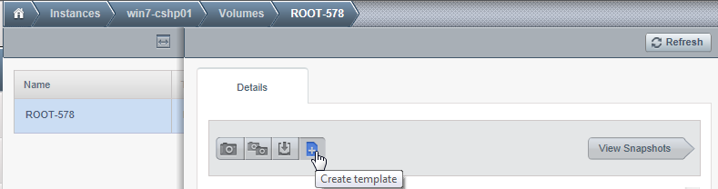

1. **Template properties**

When creating the template a dialog pops up asking for more template information. This is important data that will define if and how your desktop appears in XenDesktop!!

Name: The name of the template is used as desktop group in XenDesktop. So the user will see a desktop group with this name appearing in his WebInterface of CloudGateway area.

Description: The description is used as identification criteria for a desktop. The sync desktop script we are going to explain further down below in this document checks for the first characters used as template description. In this example the string “DEV” is used to identify this template as a desktop template. All VMs resulting from templates not having this identification string in their description will be ignored by the sync script. Please make sure to use an appropriate start string for your description here. All other description characters are not relevant for the deployment.

The other flags in the create template dialogue should be used according to customer / deployment needs (not relevant for this integration).

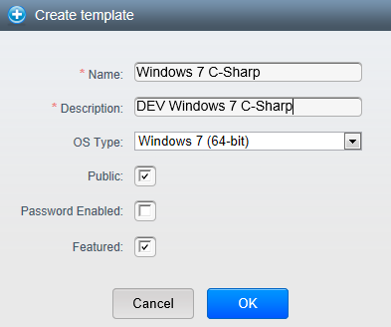

1. **Creation if instances from the template**

When the template creation process has finished, instances can be created from this template. For the instance creation process make sure that you select the appropriate values:

* Template as created previously (important)
* Compute offering used for a virtual desktop (no dependency on the functionality)
* Data disk offering (no dependency on the functionality)
* Shared network as created before (important)
* Name for the virtual machine (important)

This part is especially important. The integration described in the “CloudPlatform_auto_join_vm_to_domain” document uses the name specified in this part of the wizard as hostname for the virtual machine. Hence it’s required that the name specified here can be used as Windows name. So make sure that the naming convention and name length matches Windows hostname criteria otherwise the process will fail. Don’t leave this field empty! In case the name field is left empty, CloudPlatform will define a UUID as VM name. In the current implementation UUIDs are too long to be used as hostname (max. 15 characters). As a result the deployment would fail as well. This might be covered in future versions of the integration scripts.

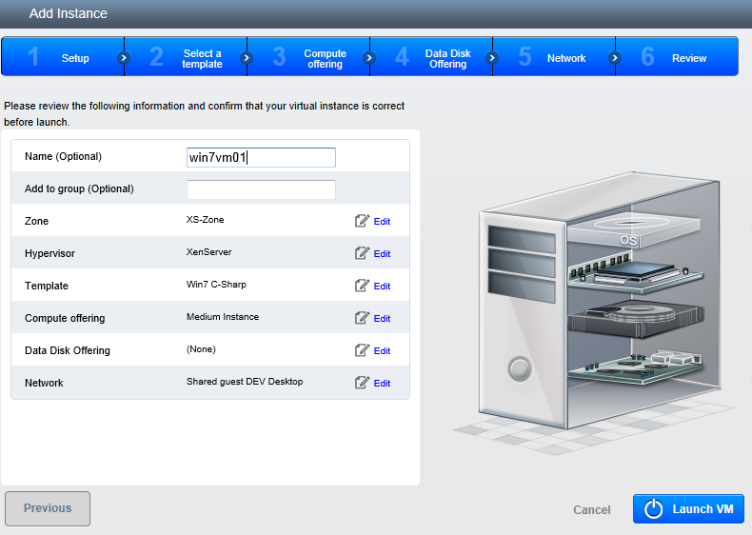

When all requirements are considered as outlined above the resulting VM should be automatically joined to the domain after the deployment process has finished. The deployment itself will take some time (~10 minutes depending on storage and server performance) due to the sysprep process and some reboots. Always make sure to deploy instances into the right shared network (Advanced zone) to enable communication between XenDesktop and the virtual desktop deployed as well as the client and the virtual desktop.

1. **Final checks**

When having deployed the first instance there’s a couple of points to check:

* 1. Active Directory integration

Check in Active Directory if the computer account for the virtual machine has been created. The account should have the same name as specified during the instance creation wizard.

* 1. VDA functionality

Check in Desktop Studio if the virtual machine deployed can be registered as an unmanaged machine in a “physical” catalog. This guide does not go through all details for this process, but gives some indication in the screenshots below. For more details please refer to the XenDesktop documentation.

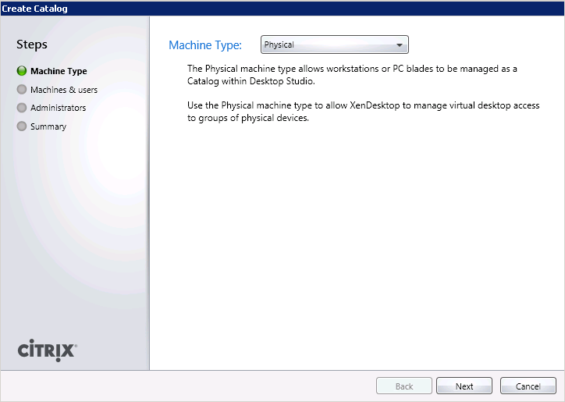

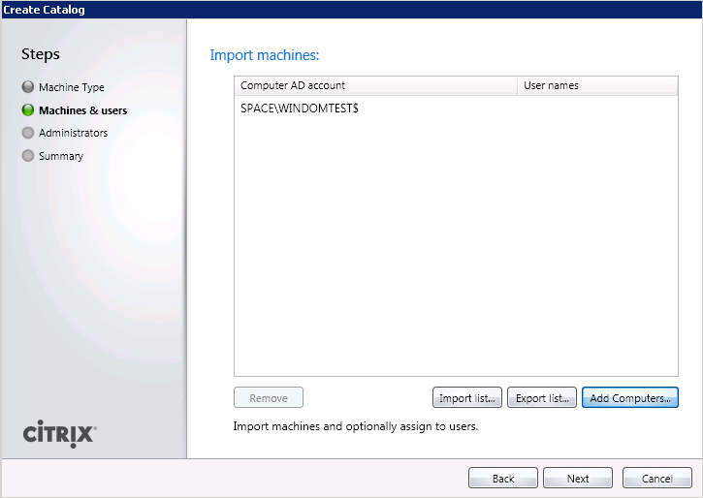

The virtual machine must show up in the registered state, like shown in the screenshot below. If this won’t be the case there’s something wrong in the network or VDA registration. It’s important to solve this issue because the subsequent processes using the sync script won’t work as well.



Integration of the CloudPlatform/XenDesktop sync script

If all steps from the previous sections have been followed, a successful manual integration of a CloudPlatform deployed desktop should work. The missing part now is an automatic registration and de-registration of a CloudPlatform deployed desktop in XenDesktop.

To enable this functionality a script is required that keeps track of the registration process and syncs CloudPlatform VMs with XenDesktop configuration. The script is called “syncccpxd.ps1”. To integrate it into the installation following steps have to be performed:

1. **Copy script to XenDesktop delivery controller**

Copy “syncccpxd.ps1” script to XenDesktop delivery controller into the directory c:\powershell

*Note: The name of the script is not relevant for it to work properly. You might find the script name enhanced by version number as part of this download (e.g. syncccpxd102.ps1).*

1. **Edit script variables**

The script has 4 variables that have to be customized according to the configuration of the customer environment:

$catalogname = 'Developer VMs'

$ccpip = '172.16.10.24'

$domain = 'space'

$templatestart = 'DEV'

$catalogname:

This is the name of the catalog that is automatically created in XenDesktop. In this catalog the virtual machines created on CloudPlatform will be registered.

$ccpip:

This is the ip address or hostname of the CloudPlatform management server which is accessible through api (port 8096). You have to make sure that this server is reachable from the XenDesktop delivery controller

$domain:

This is the active directory domain the virtual machines as well as user accounts are retrieved from.

$templatestart:

This is the string the script checks for in the template description to identify instances that should be managed by this script. It is important that this string and the string used as start characters for the template description (see sections before when creating the template) match.

Edit the variables according to your needs and save the script.

1. **Install powershell module for active directory**

As the sync script does access active directory and needs to be able to read and write data, it’s important to have the powershell module for active directory installed on the XenDesktop delivery controller host/VM.

The module can be activated in the Windows server manager as part of a feature installation:

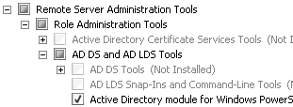

1. **Run syncccpxd.ps1**

When all preparation is done the script can be started. The script is configured to run in a loop and to refresh all 30 seconds by default.

To start the script open a cmd.exe with administrative permissions:

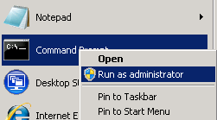

Before you run the script it might be required to set the powershell execution policy to RemoteSigned (depending on your system configuration). To do this run following commands:

* powershell
* Set-ExecutionPolicy RemoteSigned

Before you run the syncccpxd.ps1 script make sure the powershell prompt is showing up



Now simply start the script by referencing to the installation path

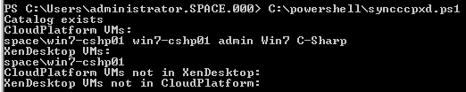

The output like in the example above shows you

* The VMs registered in CloudPlatform
* The VMs registered in XenDesktop in the corresponding catalog
* The VMs deployed in CloudPlatform, but not yet registered in XenDesktop
* The VMs registered in XenDesktop but not deployed in CloudPlatform anymore

The screen refreshes every 30 seconds and in a static environment (no new VMs deployed or deleted in CloudPlatform) it should show up like in the screenshot above: No VMs that are only in CloudPlatform and no VMs that are only in XenDesktop. When new VMs are deployed or existing VMs are deleted it will take some time until syncccpxd.ps1 registers or de-registers VMs. The time required depends on the deployment performance as well as refresh delay.

**About Citrix**

Citrix Systems, Inc. (NASDAQ:CTXS) is the leading provider of virtualization, networking and software as a service technologies for more than 230,000 organizations worldwide. Its Citrix Delivery Center, Citrix Cloud Center (C3) and Citrix Online Services product families radically simplify computing for millions of users, delivering applications as an on-demand service to any user, in any location on any device. Citrix customers include the world’s largest Internet companies, 99 percent of Fortune Global 500 enterprises, and hundreds of thousands of small businesses and prosumers worldwide. Citrix partners with over 10,000 companies worldwide in more than 100 countries. Founded in 1989, annual revenue in 2008 was $1.6 billion.

©2009 Citrix Systems, Inc. All rights reserved. Citrix®, Access Gateway™, Branch Repeater™, Citrix Repeater™, HDX™, XenServer™, XenApp™, XenDesktop™ and Citrix Delivery Center™ are trademarks of Citrix Systems, Inc. and/or one or more of its subsidiaries, and may be registered in the United States Patent and Trademark Office and in other countries. All other trademarks and registered trademarks are property of their respective owners.